*Normalization in the Area Drainage Systems Jl. East Jajartunggal III For Flood Mitigation Efforts in Surabaya - East Java*

*Nurhayati Aritonang, Kusnan, Teknik Sipil, Water Resource, Surabaya State University.* [*aritonangsipil@gmail.com*](mailto:aritonangsipil@gmail.com)

***ABSTRACT***

*Surabaya, as the second largest Metropolitan city of Indonesia is one of the major cities are often flooded. The cause of the problem of flooding that hit the city of Surabaya This is typical in some areas in the city of Surabaya, the land conversion that occurs in a very quick time due to development that is still continuing, topography Surabaya located in areas that are relatively flat and channels drainage is not able to collect rain water due to sedimentation and garbage. One example is the way Jajartunggal Timur Region III, containing the water system Jajartunggal Road East III, which is still experiencing flooding problems. Flooding in this area due to the existing channels in the area drainage systems East Jajartunggal III is not able to collect rain water causes water to spill into the street. The problem is exacerbated by reduced channel capacity due to sedimentation, debris, and the narrowing of the channel that occurs due to changes in land use by the public. To handle the problem of flooding in the Region III East Jajartunggal be reviewed overall condition of the existing channels, by evaluating existing conditions so as to put forward some alternative solutions to problems of flooding in Region III East Jajartunggal road. The results showed that these problems cause differences between runoff discharge occurring and existing, so that the channel is no longer enough rainwater on the current conditions.*

***Keywords****: Runoff rainwater, Drainage, Channel Capacity*

***A. Background***

*The ever increasing population growth and thus require an increase in the number of settlements in the region resulted in less land or green area / open area as the land of rain water infiltration into the soil decreases.*

*Surabaya City is a city that experienced an explosion of migration is high that spreads in the region-the region is uneven it is becoming a significant problem of flooding due to no longer pay attention to the drainage system well, actually in the explosion of migration are demanding eligibility facilities and adequate infrastructure.*

*Areas prone to flooding and inundation contained in Surabaya geographically has been identified as the location is very prone to flooding and waterlogging cannot be separated at the study site in a residential street Jajartunggal East III with a relatively flat topography resulting in rain water can not flow (a flow rate of the river low), rainfall per year is quite high, and the condition of drainage channels (primary, secondary and tertiary) are no longer able to accommodate and drain rain water in Gunungsari an area that has the contour of the land is hilly. Contour hilly land used as a golf course in a specific location.*

*The flooding problems in this area need to be analyzed to determine the aspects that influence the occurrence of floods, as well as how a solution to solve the problem. In this case will be further observations will be studied scientifically. From the above background, the author makes the title of "normalization utilization drainage system for the reduction of flooding in the East Jajartunggal III South Surabaya, East Java".*

***B. Purpose and Objectives***

*1. Analyze and evaluate the dimensions of the drainage system in Zone Jl. East Jajartunggal III Surabaya.*

*2. Planning repair rainwater drainage system that fits in Region Jl. East Jajartunggal III Surabaya*

*3. Analyzing the discharge of runoff that occurs in the area of ​​Jl. East Jajartunggal III, Surabaya.*

***C. Benefit***

*1. As a college library materials Hydrology*

*2. After the completions of this study are expected in each of the rainy season does not happen again inundation / flooding in the region East Jajartunggal III Surabaya.*

*3. As of library materials for students in the preparation of final project or thesis*

*4. As a material journals, national and international seminars.*

***D. Scope***

*1. What was the condition of the existing drainage channels on Jl. East Jajartunggal III?*

*2. Do the necessary repairs on the existing drainage system?*

*3. What is the amount of discharge runoff that can be accommodated by the channel?*

***LITERATURE REVIEW***

1. ***Overview***

*Bahtiar and Ilmiaty (2011), revealed that the floods caused by excessive rainfall, tidal river, land topography relatively lower than the surrounding area and poor drainage in the drain water. As well as the value of tides, rainfall intensity, the dimensions of the channel, and the slope of the channel affects the planning of the drainage system.*

1. *Analysis of Hydrology*

*Data-daily rainfall data to be searched high rainfall averages with average Algebraic Method, Thiessen Polygon Method and Method Isohyets.*

1. *Watershed (DAS)*

*Watersheds have specific characteristics associated with major elements such as soil type, topography, geology, geomorphology, vegetation and land use. Watershed management is basically aimed at the realization of the optimal conditions of resource vegetation, soil, and water, so as to give maximum benefits to human welfare and sustainable.*

1. *Rain Regional Average*

*Rainfall is required for the preparation of a draft water use is the average rainfall in the entire region concerned and not rainfall at a certain point.*

1. *Compliance Testing Distribution*

*Some conformance testing distribution used to calculate the average rainfall is the maximum area (Sosrodarsono, 1987: 27):*

1. *Flood Discharge* (Qah)
2. *Discharge of rain water is called surface runoff based on storm water runoff that occurs and the peak flow rate variables diorentasikan on the intensity of rainfall during the period of concentration and the area drainage. To calculate the discharge of rain water overflowing on a surface land use Rational method formula (Subarkah, 1980: 48). This formula is widely used for irrigation, drainage planning area is narrow. The general form of this equation as follows:*

*Q = k. C. I. A*

*where:*

*Q : The maximum flood discharge (m3 / s).*

*K : constant, Conversion Factor*

*: 0.002778 for the land in units of Ha*

*: 0.2778 to land with units km²*

*C : coefficient streaming*

*I : intensity of the average rainfall for the flood arrival time (mm / h)*

*A : area of ​​drainage*

*and become*

*Q = 0.278. CI A*

*The meaning of this formula is the case of rainfall during 1 hour with an intensity of 1 mm / hour in an area of ​​1 km2, the magnitude of the flood discharge is 0.278 m3 / s. Where would overflow flood discharge evenly for 1 hour.*

*Rational method is the oldest method was developed only to predict the magnitude of the peak discharge without seeing the big leverage discharge over time.*

*Q = 0.002778 C.I.A*

1. *Rainfall intensity (I).*

*High intensity of rain is defined as rain water per unit time in mm / hour or mm / day. The intensity of the rainfall occurring at specified intervals depending on the time period of concentration and re-taken. The intensity of rain during the time of concentration can be obtained using the formula Mononobe (Suripin, 2003: 68) as follows:*

$I= \frac{R_{24}}{24}{\left[\frac{24}{tc}\right]}^{\frac{2}{3}}$*..*

*with:*

*I = intensity of rainfall during the concentration time (mm / h)*

*R24 = daily maximum rainfall in 24 hours (mm)*

*tc = length of rain or rain konsertasi time (hours)*

*Concentration time is the length of time required by the rainwater that falls on the farthest to reach the observation point. As for calculating the concentration time in the life equation Kripich (Suripin, 2003: 82):*



*with:*

*L = length of the channel (m)*

*S = slope of the average channel*

1. *Drainage coefficient (C)*

*Drainage coefficient is the ratio between the amount of water flowing in an area due to rain with the amount of rain that fell in the area. Large drainage coefficient changed from time to time in accordance with the influence of land use and watershed.*

*The coefficient drainage in an area affected by important factors (Imam Subarkah, 1978: 42), namely:*

1. *The rain*
2. *Size and shape of the drainage area*
3. *The slope of the drainage area and the slope of the riverbed*
4. *Infiltration and percolation of soil*
5. *Soil wetness*
6. *Air temperature, wind, and evaporation*
7. *It lies to the flow direction of the wind*
8. *The capacity of the riverbed and the surrounding area*

*To plan a channel dimensions should know the actual flood discharge. It aims to avoid ponding water. To meet this goal the channel must be made quite fit the flood discharge. Flood discharge is very important in planning the drainage system. If one in determining the design discharge, then the unused drainage system will not function properly. The flow of water to be channeled taken on a large flood discharge plan, as a basis for calculating the size of the planned building.*

1. *Hydrograph Methods*

*This hydrograph method using hydrograph dimensionless function to provide a standard form unit hydrograph.*

$$Qp=(\frac{2,08xA}{tp})$$

*2. Time Concentration*

*In principle, the concentration time can be divided into (Anonymous, 1997: 13)*

*a. Inlet time (to), is the time required for the water to flow above ground level to the nearest drainage channel.*

*b. Conduit time (td), the time required for the water to flow along the channel until the specified control point downstream.*

*Time concentration is calculated by theoretical, but because the measured region is not too large, then the amount of time concentration was calculated using the following formula Kirpich (Suripin, 2004)*

$$tc=\{\frac{(0,87xL^{2)0,385}}{1000xs}\}$$

*where:*

*tc = concentration time (hours)*

*L = length (km)*

*S = slope of the mean*

*To calculate the concentration time can also be used the following formula:*

*Tc = to + td*

*by:*

$to=\{\frac{2}{3}\text{x 3,28} x L x\frac{n}{√s}\}$. dan $td=Ls/60V$

*Where:*

*n = number manning roughness*

*S = slope*

*L = length of flow path above the land surface (m)*

*Ls = length of flow path in the channel*

*V = velocity of flow in the channel (m / sec)*

***OBJECTIVES AND BENEFITS RESEARCH***

1. ***Objective***

*To identify and evaluate the factors that cause flooding in the municipality of South Surabaya specialized in the area of ​​Jl. JajartunggalTimur III, in an attempt to provide an alternative treatment to minimize the routine problems of drainage and flooding in the area JajartunggalTimur III. Although the study site on the upstream side is higher than the downstream, then this should not be the cause of flooding in the area. This type of research used in this study is descriptive research is a case study with field observations (Case Study and Field Reasearch). The data required in this study are as follows:*

* 1. *Data Rainfall*

*Rainfall data used is the rainfall data over the last 10 years.*

* 1. *Data Location*

*These data include photographs of site conditions to be studied.*

***B. Location Research***

*The research location is housed in the area of ​​East Jajartunggal Gunungsari III Surabaya which includes residential areas and local road infrastructure.*

***C. Object and Scope of the Study***

*The object of this research is in the area around the highway road Bhumi Marines East Jajartunggal III Gunungsari Surabaya. The scope of this study includes the analysis of rainfall and drainage channel network, as well as the analysis of drainage and environmental conditions that exist at the site.*

***D. Sources of Data Research***

* 1. *Primary Data Primary data is data obtained through calculation and direct observation in primary lapangan.Data in this study includes a description of environmental conditions and darinase channels.*
  2. *Secondary Data Secondary data is data obtained melelui some references such as journal studies, data from statistics agencies as well as from research terdahulu.Adapun secondary data from this study include data from agricultural production of rice, rainfall data and the condition of the area Bhumi Marines goegrafis Gunungsari Surabaya.*

***E. Benefits Research***

*So that when the rainy season arrives, the downstream areas, especially areas of research that are no longer flooded so that the downstream especially East Street area Jajartunggal III, because in an area consisting of a residential dormitory navy and public facilities such as swimming pools, houses of worship, schools. During the event of heavy rain during the time of ½ to 1 hour then the downstream areas were flooded up to one meter.*

***RESEARCH METHODOLOGY***

1. *Overview Location*

*Jajartunggal road east region III has an area of ​​105.5 ha ± with boundaries as follows:*

*North : Jl. H.R. Muhammad*

*South : Jl. Gunung Sari*

*East : Village Jogoloyo*

*West : Village Jogoloyo*

*The condition of the drainage system in the area of ​​East Jajartunggal III is not good. Lots of drainage channels covered by soil and many drainage channels had been separated into a mixed back. Channels that are in every home comes down to the creek. The water in the creek is brownish black in color because of the existing drainage system is not offset by the wastewater treatment plant so that waste water flowing into the creek remains a waste that can cause various diseases.*

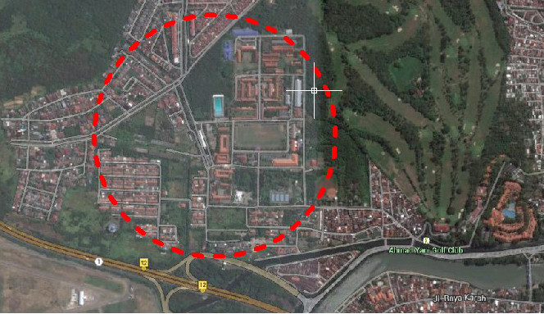

*Figure 1 : Case studies Street Jajartunggal East III*

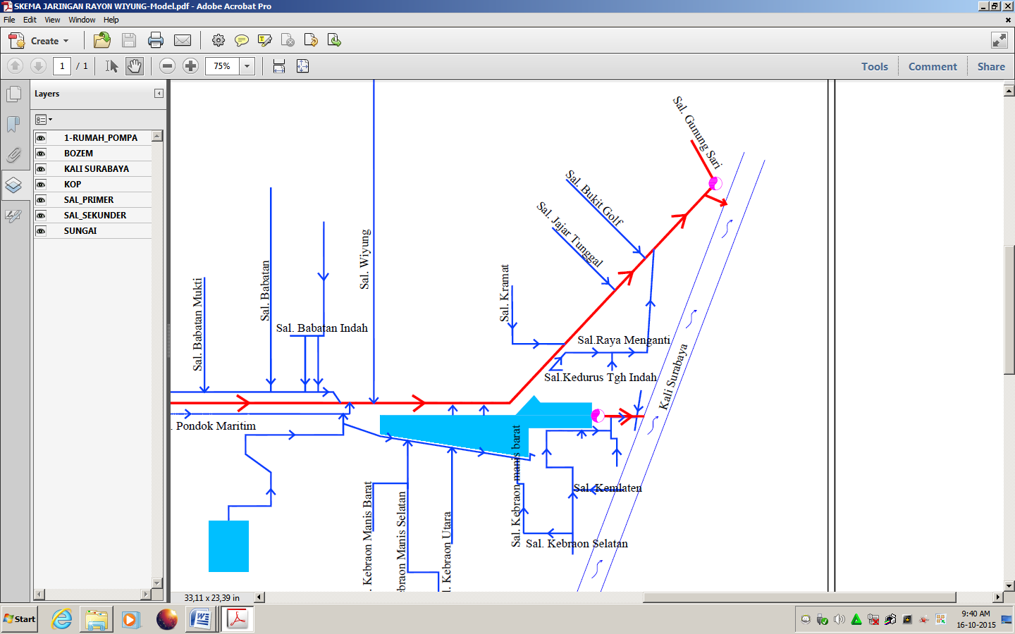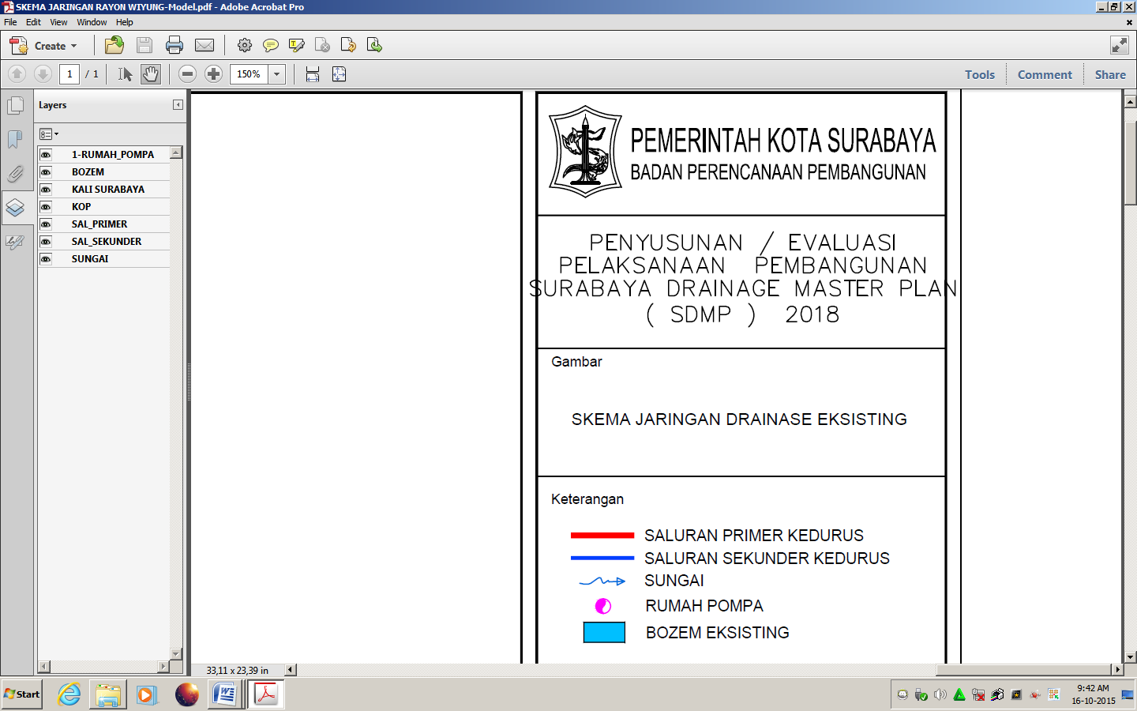

*Figure 2 : Schematic drainage network Jajartunggal road east region III*

***B. The data required***

*After review of the field data collection and data processing can be performed the following:*

1. *Studi literature by collecting theories that support.*
2. *The secondary and primary data collection.*
3. *Analysis of hydrological by searching rainfall data, sediment data.*
4. *Calculate the flood discharge.*

*a. Calculate the intensity of the rain*

*b. Calculating drainage coefficient*

*c. Calculating the rainwater discharge.*

***C. Data Primer***

*In the case study area locations Jajartunggal east III road and its surroundings in accordance with the terms of research methodology obtained some data including primary data and secondary data. Primary data obtained from searches directly to the location of the study area, whereas primary data obtained from debriefing by local residents as well as from relevant agencies.*

*Primary data obtained here include: Dimensions of the drainage system in the location, existing state portrait of the channel and the location of the study.*

*1. The size Drainage Channels*

*a. Channel Dimensions*

*D. Secondary Data*

*From the results of the survey conducted directly to the area of ​​case studies obtained secondary data which includes the results of interviews that the East Road area Jajartunggal III and surrounding areas including densely populated areas in the south of Surabaya. Corresponding results of the survey interviews conducted with local residents obtained some conclusions include:*

*a. Rain that occurs in the area where these studies often occur and when it rains lasted long enough and cause flooding. Rain can be concluded at this location included in a high intensity.*

*b. At the time of floods in the area of ​​the study area average water level almost reached the knees of adults, or about 30 cm.*

*c. In the area of ​​study locations that cause flooding due to high rainfall intensity and duration.*

***E. Annual Rainfall Data***

1. *Subdistrict Daily Rainfall Data Wonokromo2000 – 2012*
2. *Daily Rainfall Data District of Simo 2000 – 2012*
3. *Subdistrict Daily Rainfall Data Kedung Cowek 2000 – 2012*

*1. Analysis of Results of Arithmetic*

*Summary data of rain 10 years of post wonokromo, Simo and Kedung Cowek*

* *Calculating the average precipitation in the form of log*

Log = $\frac{\sum_{t=1}^{n}{\log{X}}}{n}$

= $\frac{19,86646134}{10}$ = 1,98664613

* *Calculating the standard deviation value deviation Sx:*

Sx=

= = 0,0983

* *Calculate the coefficient of skewness Cs:*

Cs = $\frac{\sum_{i=1}^{n}{{(\log{X-\log{X)}}}^{3}}}{\left(n-1\right)\left(n-2\right){Sx}^{3}}$

= $\frac{-0,0082927898}{\left(10-1\right)\left(10-2\right){0,0983}^{3}}$ = -0,1211

***THE RESULTS ACHIEVED***

1. *Frequency Analysis of Rainfall*

*In this study, the rainfall data used is the rainfall data from one station, the station Dukuh Pakis obtained from the Meteorology, Climatology and Geophysics over the last 10 years. Table 1 Rainfall Data*

|  |  |
| --- | --- |
| *Year* | *Station (m3)* |
| *2002*  *2003*  *2004*  *2005*  *2006*  *2007*  *2008*  *2009*  *2010*  *2011* | *100*  *152*  *124*  *118*  *122*  *145*  *109*  *113*  *110*  *155* |

*Source: Meteorological, Climatology and Geophysics Surabaya*

1. *Rainfall Analysis Plan*

*Rainfall statistics parameters are as follows:*

*Standard deviation (Sx) = 0.051*

*The coefficient of skewness (Cs) = 0.0686*

*LogXt = LogX + Kt S Log*

*Table 2. Rainfall Period Repeat*

|  |  |  |  |  |  |
| --- | --- | --- | --- | --- | --- |
| *Repeat Period (Years)* | *Log X* | *S Log X* | *Kt* | *Log Xt* | *Xt (Rainfall)* |
| *2*  *5*  *10*  *25* | *1.981*  *1.981*  *1.981*  *1.981* | *0.0519*  *0.0519*  *0.0519*  *0.0519* | *-0.01*  *0.837*  *1.288*  *1.773* | *1.981*  *2.024*  *2.047*  *2.072* | *95.665*  *105.72*  *111.49*  *118.05* |

1. *Rain Intensity Analysis*

*Before searching intensity of rain to the design must be known in advance the time of concentration (tc) needed rain that falls from the furthest point to the observation point (CP). For Jajartunggal Channels III and Taman Bukit Pakis:*

*Note:*

*n = 0,013,*

*Lo = 92.75 m,*

*Ls = 296.5 m,*

*So = 0.001,*

*v = 0.4 m / s,*

*R = 105.72 m*

$$to={\left(\frac{2}{3}x3,28x92,75\frac{0,013}{\sqrt{0,001}}\right)}^{0,167}=2,093$$

$$td=\frac{1}{60}\frac{296,5}{0,4}=12,354 menit$$

$$tc=2,093+12,354=14,447menit=0,241$$

*So, $I=\frac{105,72}{24}{\left(\frac{24}{0,241}\right)}^{\frac{2}{3}}=94,69$ mm / h*

1. *Debit Analysis Plan*

*For Jajartunggal Jalan Pakis III and Taman Bukit Pakis*

*Rain water discharge:*

*Known: C = 0.69, I = 94.69 mm / h,*

*A = 2,32 Ha*

*Qah = 0.00278 x 0.69 x 94.69 x 2.32 = 0.420 m3 / s*

*Dirty water discharge:*

*Sp = 330.53 inhabitants / Ha,*

*A = 2,32 Ha,*

*Po = Sp x A*

*= 330.53 inhabitants / ha x 2,32 Ha*

*= 766.83 soul*

*The population of the five year period in the command area:*

*Pn = Po (1 + m)*

*= 838.37 person*

*Average sewer = 70% water needs. On the True Path majority of households are building it, the average waste water disposal is*

*= 250 liters / person / day x 70%*

*= 175 liters / person / day = 2.025 x 10-6 m3 / sec / person*

*Debit generated in the 5 year period are:*

*Qak = average wastewater x Pn x FDP*

*Qak = 2.025 x 10-6 x 838.37 x 4.5*

*Qak = 0.00764 m3 / s*

*Then Debit Plan (Qr) = Qah + Qah = 0.420 + 0.00764 = 0.4276 m3 / sec*

*3. Debit Channel Analysis Method with Chi Square*

*Calculated discharge at each observation point (CP) aims to determine the total discharge large at each point of observation, which is then used as an evaluation of the existing drainage discharge chute.*

*Table 3 Evaluation Plan Against Debit Channel Dimensions*

|  |  |  |  |  |  |  |  |  |  |  |
| --- | --- | --- | --- | --- | --- | --- | --- | --- | --- | --- |
| *Name Street* | *Inlet* | *channel form* | *Channel dimensions* | | | *(Td)* | *Qs (1)* | *Qs (2)* | *Qr* | *Evaluation* |
|  |  | *a* | *b* | *h* |
|  |  | *(m)* | *(m)* | *(m)* | *(m)* | *(m3/det)* | *(m3/det)* | *(m3/det)* |
| *Jajar Tunggal III* | *IIb* | *Square* | *-* | *0,5* | *0,7* | *0,1* | *0,755* | *0,642* | *0,689* | *Not OK* |
|  | *IIe* | *Square* | *-* | *0,5* | *0,7* | *0,1* | *1,942* | *1,796* | *1,884* | *Not OK* |
| *Taman Bukit Pakis* | *IIa* | *trapezoid* | *1.00* | *0,75* | *0,8* | *0,4* | *0,923* | *0,333* | *0,488* | *Not OK* |

*Source: Calculation results*

*Specification Table:*

*Cp : ​​Observation Point Td : thick sediments*

*a : The width of the channel's upper Qs (1) : Debit clean channel*

*b : The width of the bottom of the channel Qs (2) : Debit channel with sediment*

*h : height channel Qr : Debit total plan*

***4. Design of New Drainage Channels***

*Drainage design applied in this case is to deepen and widen the channel dimensions. This is done by considering some of the technical accordance with the conditions of an existing channel in the study area. The considerations taken are:*

*1. Consider the availability of land at the site of drainage.*

*2. Consider minimum speed to prevent sedimentation.*

*For Jajartunggal III Drainage Street and Jalan Bukit Pakis, according to its function of this channel is collecting ducts. Therefore, these channels have a considerable risk to sedimentation. To anticipate this, it is necessary to increase the dimensions of tiny channels (semi-circle) at the bottom of the channel, where the channel is in accordance with the concept of a smaller discharge can stream sedimentation when no rain. Dimensions of these channels can be searched according to the flow of daily housekeeping on site.*

*Table 4 Dimensions New channels with discharge chute clean*

|  |  |  |  |  |  |  |  |  |  |
| --- | --- | --- | --- | --- | --- | --- | --- | --- | --- |
| *Nama* | *Inlet* | *Bentuk* | *Debit* | *Dimensions New Channel* | | | | *Q channel* | *Evaluasi* |
| *Jalan* | *Saluran* | *Rencana* | *a* | *b* | *h* | *Slope* | *Netto* |
|  |  | *(m3/det)* | *(m)* | *(m)* | *(m)* | *(m3/det)* |
| *Jajartunggal III* | *IIb* | *Persegi* | *0,689* | *-* | *0,7* | *0,8* | *0,00202* | *0,755* | *OK* |
|  | *IIe* | *Persegi* | *1,884* | *-* | *0,7* | *0,8* | *0,00301* | *1,942* | *OK* |
| *Taman Bukit Pakis* | *IIa* | *Trapesium* | *0,488* | *1.00* | *0,75* | *0,8* | *0,0015* | *0,923* | *OK* |

***CONCLUSIONS AND RECOMMENDATIONS***

***A. Conclusion***

*Based on the description and analysis of the calculation, it can be concluded that:*

*1. Contour uneven ground cause water to collect in a certain point.*

*2. Conditions rainwater drainage channels where the channel paths are less efficient in draining a large water discharge and sewerage in the area of ​​the Marine Bhumi Gunungsari Surabaya and surrounding areas is not good.*

*3. For rainwater drainage necessary repairs because of existing drainage channels can not accommodate existing runoff discharge. As for the drainage of waste water is also necessary repairs for existing channels do not function properly due to sedimentation sufficient in causing blockage.*

*4. From the analysis of the discharge, acquired all of the channel can not accommodate the discharge plan (Qr> Qsal) with details as follows:*

*a. There are five (5) channels that should be redesigned, namely: - CP4, CP5, CP11 and CP12 to discharge plan Qr = 0,467 m3 / s with channel dimensions square, h = 70 cm and b = 75 cm.*

*b. Almost all channels are met by garbage and minimize sedimentation capacity of drainage channels and interfere with the rate of water*

*5. In anticipation of sediment in the channel necessary to add a small channel dimensions (half circle) at the bottom of the channel, where the channel is in accordance with the concept of a smaller discharge can stream sediment when no rain. Therefore, in planning the dimensions of the semicircular canals of this, according to the debit sought daily housekeeping. The details are as follows:*

*a. For Jalan Jajartunggal III with a diameter of 40 cm.*

*b. To Jalan Taman Bukit Pakis with a diameter of 45 cm.*

*6. From the analysis, the cause of a puddle in the road agencies in the area Fern Hill Estate is a drainage channel that is not functioning properly due to garbage, sedimentation and grass, besides the dimensions of the drainage channel at some point that does not meet.*

*7. The impact caused by floodwaters in agencies around the script is:*

*a. Stagnant water / flood damage pavement, which resulted in pavement lifespan is shorter than the design life.*

*b. Stagnant water / flood very disturbing mobility of road users because it resulted in traffic jams, especially inundation areas are at a crossroads.*

***B. Suggestions***

*The advice given to cope with floodwaters on the road around the script is:*

*1. Change the cross section of the drainage channel by enlarging existing drainage channels.*

*2. It should be the role of society in order to care for the environment, one of which is by not throwing garbage into drainage channels.*

*3. Surabaya City government should periodically dredge sedimentation in the drainage channel, because it was far cross section of the drainage channel*

*Stage plan that will be implemented in the next stage is to restore normal drainage channels, especially at shift derivative which has a sizable sediment and make the widening of the gutter in the upstream, especially in front of the Hangtuah elementary school and making simple bosem at the headwaters of the river before arriving at Rolak*

**DAFTAR PUSTAKA**

Anik, Sarminingsih. 2007. Kajian Alternatif Penanggulangan Banjir (Studi Kasus Sungai Ladapa Di Kabupaten Gorontalo).*Jurnal PRESIPITASI, Vol. 3 No.2 September 2007, ISSN 1907-187X*

Badan Meteorologi, Klimatologi dan Geofisika Surabaya.

Badan Pusat Statistik Kota Surabaya, 2002.

Dirjend. Pengairan Dept. Pekerjaan Umum,1986, *Standar Perencanaan irigasi Kriteria*

Ilmiaty, R.S., dan Bahtiar, 2011, *Analisis Sistem Drainase Pada Kawasan Perumahan*

Kusnan. 2010. *Drainase Perkotaan 1*. Surabaya : Unesa.

Nanik, Suryo, dkk. 2012. Model Bahaya Banjir Menggunakan Penginderaan Jauh Di Kabupaten Sampang.*Jurnal Penginderaan Juh, Vol. 9 No.1 Juni 2012, 52-66*

Novirina, Hendrasarie. 2005. Evaluasi Banjir Pada Area Drainase Kali Kepiting Dan Kali Kenjeran Surabaya Timur.*Jurnal Rekayasa Perencanaan, Vol. 2, No. 1, Oktober 2005*

Perencanaan Bagian Saluran (KP-03). CV. Galang Persada, Surabaya.

*Serikat Ogan Permata Indah Sub DAS Jakabaring Kota Palembang*, Unsri, Palembang.

Seyhan, Ersin, 1990, *Dasar-dasar Hidrologi, Gadjah Mada University press*, Yogyakarta

Sosrodarsono, Suyono, 2003, *Hidrologi untuk pengairan, Pradnya Paramita*, Jakarta.

Sri, Firdayanti. 2014.*Studi Penyebab Terjadinya Banjir Di Kawasan Permukiman Kelurahan Sungai Sapih Kecamatan Kuranjikota Padang*.Padang : Skripsi

Suripin, 2004, *Sistem Drainase Perkotaan Yang Berkelanjutan,* Edisi Pertama, Andi, Yogyakarta.

Sutopo, Purwo Nugroho. 2002. Evaluasi Dan Analisis Curah Hujan Sebagai Faktor Penyebab Bencana Banjir Jakarta.*Jurnal Sains & Teknologi Modifikasi Cuaca, Vol. 3, No. 2, 2002, 91-97*

Triatmodjo, B., 2003, *Hidrologi Terapan*, Beta Offset, Yogyakarta.

Wilson E. M. 1990. *Hidrologi Teknik*. Bandung : ITB Bandung.