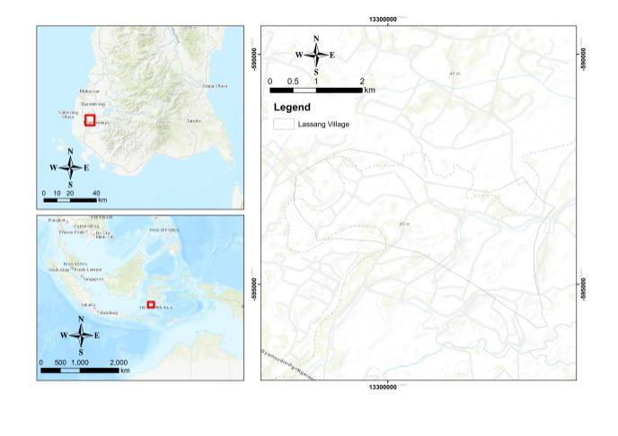

Figure 1 Lassang Map (source: google earth)

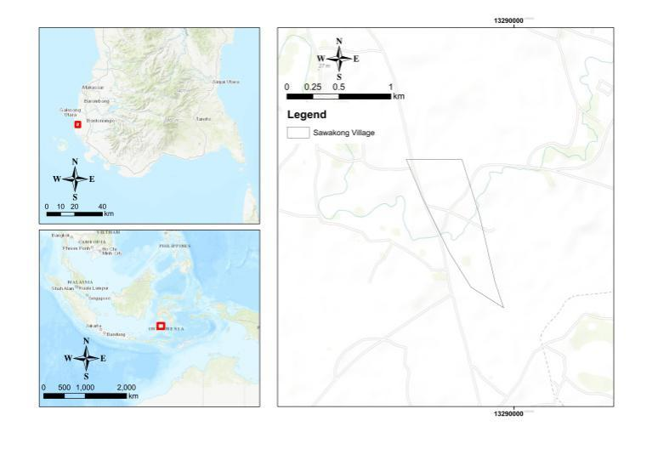

Figure 2 Sawakong Map (source: google earth)

Table 1 Variables of marital satisfaction, job satisfaction, and decision-making

|  |  |  |  |
| --- | --- | --- | --- |
| Part | Variables | | Description of Indicator |
| Marital Satisfaction | Household Responsibility | Social process related to the wellbeing of families and construction of gender. | |
| Raising Children | Financial and emotional resources devoted to raising children. | |
| Consciousness | Statement about point of view of spouse and how the respondent resolves conflict in marriage. | |
| Partnership | Support in workplace and communication with partner (discuss problems faced by couple). | |
| Job Satisfaction | Enjoyment of Work | Assesses whether workers have a dream job, a comfortable job, or a comfortable workplace. Farming is a regular part of their lives. | |
| Leisure Time | Examines the relationship between work hours and leisure time among female farmers. | |
| Work Environment | One of the key challenges for any business is to satisfy its employees in order to adapt to the ever-changing and evolving environment, achieve success, and remain competitive. To increase employee efficiency, effectiveness, productivity, and job commitment, businesses must satisfy employee needs by providing good working conditions. | |
| Economic Dimension | Women in agriculture are more likely to work as unpaid family labourers. Salary and other material benefits emerge as a significant dimension of satisfaction in almost all studies of employee satisfaction. | |
| Decision-Making | Thoroughness | Refers to a careful and comprehensive approach to choosing a course of action. | |
| Control | Control systems are grounded in the idea that people will unfailingly accept legitimate authority. | |
| Hesitancy | Refers to slowness in acting or deciding due to doubt or uncertainty. | |
| Social Resistance | Refers to collective actions or attitudes taken by individuals or groups to oppose or challenge a decision made by those in power. | |

Source : author

Table 2 Socioeconomic characteristics of the respondents

|  |  |  |  |  |  |  |  |  |
| --- | --- | --- | --- | --- | --- | --- | --- | --- |
| Factor | | | Lassang | | | Sawakong | | |
| n=29 | Mean | SD | n=41 | Mean | SD |
| Age (years) | | |  | 38.55 | 9.6 |  | 34.77 | 10.19 |
|  | | Under 20 | 1 | 3 |
| 21–30 | 4 | 12 |
| 31–40 | 12 | 13 |
| 41–50 | 8 | 10 |
| 51–60 | 4 | 3 |
| Educational Background | | |  | 7.24* | 3.9 |  | 10.43* | 3.1 |
|  | No Education | | 5 | 0 |
| Elementary School | | 8 | 9 |
| Junior High School | | 10 | 10 |
| Senior High School | | 6 | 17 |
| Undergraduate | | 0 | 5 |
| Farmland Size (hectares) | | |  | 0.67 | 0.89 |  | 0.18 | 0.46 |
|  | 0.1–1 | | 0 | 10 |
| 1.1–2 | | 2 | 5 |
| 2.1–3 | | 1 | 6 |
| 3.1–4 | | 0 | 0 |
| Landless Farmer | | 26 |  |  | 20 |  |  |
| Off-Farm Work | | |  |  |  |  |  |  |
|  | Crafting | | 0 | 21 |
| Teacher | | 0 | 3 |
| Shop Owner | | 5 | 7 |
| Livestock | | 22 | 7 |
| Other | | 2 | 3 |
| Total Household Income (IDR/month) | | |  | 1098.1 | 622.94 |  | 931.21 | 498.76 |
|  | 0–500.000 | | 4 |  |  | 9 |  |  |
| 501.000–1.000.000 | | 12 |  |  | 23 |  |  |
| more than 1.000.000 | | 13 |  |  | 9 |  |  |

* Years in education

Table 3 Respondents’ score on marital satisfaction, job satisfaction, and decision-making

|  |  |  |  |  |  |  |  |
| --- | --- | --- | --- | --- | --- | --- | --- |
|  | | | Perfect Score | Max | Min | Mean | SD |
| Marital Satisfaction (n=70) | | | 85 | 77 | 30 | 56 | 9.176 |
|  | | Household  Responsibility | 25 | 23 | 7 | 17.9 | 33.2 |
| Raising Children | 20 | 20 | 7 | 14.3 | 19.4 |
| Consciousness | 25 | 25 | 6 | 16.9 | 21.6 |
| Partnership | 15 | 15 | 5 | 10.6 | 42.3 |
| Job Satisfaction On-Farm (n=70) | | | 85 | 71 | 25 | 52.87 | 8.875 |
|  | Enjoyment of Work | | 20 | 17 | 5 | 12.61 | 18.01 |
| Leisure Time | | 15 | 14 | 3 | 9.6 | 31.05 |
| Work Environment | | 25 | 22 | 8 | 13.26 | 30.96 |
| Economic Dimension | | 25 | 23 | 6 | 14.41 | 11.1 |
| Job Satisfaction Off-Farm (n=70) | | | 55 | 50 | 27 | 36.2 | 6.35 |
|  | Enjoyment of Work | | 20 | 19 | 5 | 12.61 | 12.8 |
| Work Environment | | 15 | 14 | 3 | 9.67 | 19.9 |
| Economic Dimension | | 20 | 19 | 6 | 14.1 | 15,4 |
| Decision-Making (n=70) | | | 65 | 55 | 24 | 42.2 | 6.88 |
|  | | Control | 25 | 23 | 8 | 16.2 | 31.21 |
| Social | 15 | 15 | 3 | 10 | 26.58 |
| Hesitancy | 10 | 10 | 2 | 6.19 | 3.53 |
| Thoroughness | 15 | 15 | 4 | 9.86 | 21 |

Table 4 Correlation between marital satisfaction, job satisfaction, and decision-making

|  |  |  |  |  |  |
| --- | --- | --- | --- | --- | --- |
|  | | | | | |
|  | | Marital | Job On-Farm | Job Off-Farm | Decision-Making |
| Marital | Pearson Correlation | 1 | .445** | .213* | .232* |
| Sig. (2-tailed) |  | .000 | .076 | .054 |
| N | 70 | 70 | 70 | 70 |
| Job On-Farm | Pearson Correlation | .445** | 1 | .481** | .489** |
| Sig. (2-tailed) | .000 |  | .000 | .000 |
| N | 70 | 70 | 70 | 70 |
| Job Off-Farm | Pearson Correlation | .213* | .481** | 1 | .345** |
| Sig. (2-tailed) | ,076 | .000 |  | .003 |
| N | 70 | 70 | 70 | 70 |
| Decision-Making | Pearson Correlation | .232* | .489** | .345** | 1 |
| Sig. (2-tailed) | .054 | .000 | .003 |  |
| N | 70 | 70 | 70 | 70 |
| ** Correlation is significant at the 0.01 level (1-tailed)  * Correlation is significant at the 0.05 level (1-tailed) | | | | | |

Table 5 Effect of farmland ownership on marital satisfaction and job satisfaction

|  |  |  |  |  |  |  |  |
| --- | --- | --- | --- | --- | --- | --- | --- |
|  | | | | | | | |
|  | | B | SE | Wald | df | Sig. | Exp(B) |
| Step 1a | Marital | −.044 | .043 | 1.038 | 1 | .308 | .957 |
| On-Farm | 059 | .051 | 1.328 | 1 | .249 | 1.061 |
| Off-Farm | .079 | .058 | 1.881 | 1 | .170 | 1.082 |
|  |  |  |  |  |  |  |
| Farmland | −3.485 | 2.681 | 1.690 | 1 | .194 | .031 |
| a. Variable(s) entered on step 1: Marital, On-farm, Off-farm, Farmland. | | | | | | | |

Table 6 Effect of total revenue on marital satisfaction and job satisfaction

|  |  |  |  |  |  |  |  |  |  |  |  |  |  |  |  |  |  |  |  |  |
| --- | --- | --- | --- | --- | --- | --- | --- | --- | --- | --- | --- | --- | --- | --- | --- | --- | --- | --- | --- | --- |
| |  |  |  |  | | --- | --- | --- | --- | | Independent Variable | Model I | Model 2 | Model 3 | | Dv Total Income |  |  |  | | Marital Satisfactionc | 1.805 (0.043)** | 477.504 (<.001)* | 6.610 (0.14) | | On-farma | 1.059 (0.422) | 305.148 (<.001)* | .933 (.339) | | Off-farmb | 3.948 (<.001)* | 749.024 (<.001)* | 54.589(<.001)* | |

|  |
| --- |
| a. R Squared = .361 (Adjusted R Squared = .020)(on-farm proportion) |
| b. R Squared = .678 (Adjusted R Squared = .506)(off-farm proportion) |
| c. R Squared = .490 (Adjusted R Squared = .219) (marital proportion) |

Table 7 Effect of educational background on marital satisfaction and job satisfaction

|  | | | | | | |
| --- | --- | --- | --- | --- | --- | --- |
|  |  | Marital | Job On-Farm | Job Off-Farm |
| Educational Background | Pearson Correlation | .295* | .378** | .290* |
| Sig. (2-tailed) | .013 | .001 | .015 |
| N | 70 | 70 | 70 |
| ** Correlation is significant at the 0.01 level (2-tailed)  * Correlation is significant at the 0.05 level (2-tailed) | | |  |  |
|  | | |  |  |  |  | |