**Taxonomic Notes on *Passiflora edulis* var. *flavicarpa* Deg.**

**Bidyut Phukon 1* and Chayanika Bordoloi 2**

**1*, 2**Department of Botany, Royal School of Life Science,

The Assam Royal Global University, Guwahati-781035, Assam, India.

**1\***Corresponding author’s, e-mail:[bidyutphukon1997@gmail.com](mailto:bidyutphukon1997@gmail.com)

**Abstract**

The taxonomic study of a plant is an important aspect of plant research, as it allows the most complete view of the natural habitat of any plant species. The main purpose of the present work is to provide a detail investigation of the *Passiflora edulis* var. *flavicarpa* Deg. carried out from the month of April, 2020, growing in the area of Nakachari, Jorhat District, Assam, India. A complete workout on the different parts of the plant belongs to the family Passifloraceae is done to understand the significance of these features in systematic. Paper also reflects the various phytochemical constituents present in the *Passiflora* fruit also commonly known as Passion fruit which is utilized in pharmacology and by other ways in different ethnic groups of North Eastern India as a vital source of medicinal treatment. The findings clearly express that *Passiflora* species exhibits all advanced morphological characteristics of present day Angiospermae land plants and also reported that tendrils perform the role of physical support. Towards the end the study it is also concludes with the beneficial outputs of *Passiflora edulis* from the agronomical point of view that can be easily achievable if the input through cultivation would be uniform as well as dynamic. Based on the various literature surveys, it was found that such detail taxonomic works on the species were not studied and recorded from the study area earlier. Such comprehensive work on *Passiflora edulis* var. *flavicarpa* provides an empirical basis for the identification of the species.

**Keywords:** *Passiflora*;Passifloraceae; Morphological; Taxonomic; Nakachari.

1. **Introduction**

The word *Passiflora* is a Latin word “Passio” and it was first discovered by Spanish biologist in 1529 and it was found to be a symbol for "Passion of Christ" (Patel et al.,2011). The word ‘*Passiflora’* itself indicates with two vital meaning- ‘*Passio’* means ‘passion’, whereas ‘flos’ indicates a ‘flower’. The *Passiflora* species, which belongs to the family Passifloraceae comprises nearly of about 400 species (Montanher et al., 2007). The distribution of the plant *Passiflora edulis* are mostly found in the tropical and temperature regions of the World, however they are also rarely found in Asia, Australia, and tropical Africa (Patel, 2009). In the early 20th century, the species of *Passiflora* were introduced in the Nilgiris, Coorg and Malabar areas of South India and other regions of North India, mainly in Himachal Pradesh, North East states of Manipur, Mizoram, Meghalaya, Nagaland (Tripathi, 2018). A few important species of *Passiflora* includes: *P. mollissima* Bayley, *P. calcaratu* Mast., *P. lechenwltii* DC., are accepted as an Indian origin with pharmacological properties (Bombardelli et al.,1975). In Assam the Department of Agriculture with the help of few NGOs has taken initiatives for the cultivation of *Passiflora* species in Karbi Anglong district. Karbi Anglong district is recognized as one of the rich floral diversity regions of Assam and also for 5 Wildlife Sanctuaries and thus the district is considered as a profitable region for production of high amount of quality Passion fruit which contains medicinal value (Mipun et al., 2019).

A *Passiflora* species was identified at Nakachari area of Jorhat District, Assam, India, was one of the unique plant species observed for first time in this area since the month of March, 2020. According to the local peoples of the Nakachari area there is no such amount of basic information how this particular species grew in these places from where and how the origin took place. But from the botanical prospect, it is possible to hypothesis that may be the birds or any insects carried the plant material or the seeds from other regions or different parts of the country. Whatever may be the origin the interesting point to be noted was that since the month of March, 2020, *Passiflora edulis* has been the centre of attraction for the localities and increased the demand to full fill the thirst of knowledge to know more and get insightful information. In a previous research study from China conducted on passion fruit through a supercritical CO2 (Carbon dioxide) extraction processes with the application of RSM method (Response Surface Methodology) detected the responses of optimum extraction parameters and also reported edible oils from the seeds (Liu et al., 2009). Another investigation from the year 2014 critically screened the stem part and leaves to estimate the TPC (Total Phenolic Content) accurately of different varieties of *Passiflora* and was also able to account essential constituents (Ramaiya et al., 2014). *P. edulis* plant known to have medicinal value and its importance lies in having various medicinal compounds.

From the morphological point of view, *Passiflora edulis* holds some of the key characteristic features which include green leaves with a very unique shape and size, leaves are heterophylly, herbaceous stems, tendril bearing climbers, roots and most importantly the reproductive part i.e, the flower with variation of many colour from all angle. The green leaves of *Passiflora* exhibits the ‘heterophylly’ condition as it has two distinct shaped leaves within the same plant body.

The present paper deals with the taxonomic study of the *Passiflora edulis* in Nakachari area of Jorhat district, Assam that in the identification and systematic. All the important observations were incorporated in the study with necessary photographs are captured for proper analysis and detailed explanation.

1. **Materials and Methods**

The present investigation on Passiflora was conducted from the month of April to May of 2020, at Nakachari area of Jorhat District, Assam, India. To study the morphological parts of the plant and different stages from flowering to fruiting a daily routine observation has been done and recorded practically in a notebook and photographs were taken in various stages with full focus. Necessary plant parts are isolated and dissected and herbarium was prepared (Jain and Rao, 1977). A survey was conducted with the localities of this region through direct conversation and telephonic contact, to extract essential data, if found about this plant. For proper identification of the species microfilms of herbarium specimens of online databases of various herbaria like Kew Royal Botanical Gardens (K), National Herbarium and Plant Laboratories, Missouri Botanical Gardens (MO) etc were consulted. The names of taxa were verified by online database of Plant list for Angiosperm version 1.1, Index (*http/www.plantlist.org.)*, Kewensis version-2.0 (*http/www.ipni.org.)*. The author also consulted, “Herbal Medicines” 3rd edition (2007) (Barnes et al., 2007) and “Encyclopedia of Plants and Flowers” New Edition (2019) (Brickell, 2019) for proper and correct identification.

1. **Results**

*3.1 General Description*

Botanical Name: *Passiflora edulis* var. *flavicarpa* Deg.; Assamese Name: Lata-bel, Lata bael, Junuka phul; Habit: Herbaceous, Perennial, woody, tendril bearing climber, a vine with densely hispid branchlets; Habitat: Terrestrial; Distribution: Nakachari, Jorhat, Assam, India; Type: Flowering; Flowering: April-May(Jorhat, Assam, India);Fruiting: May;Pollination: Insects, cross-pollination. Leaves 3-5 lobed, green, heterophylly, alternate, stipules, margin sub entire to ciliate, apex acute, length 14cm and 13cm, width 8cm and 13cm.

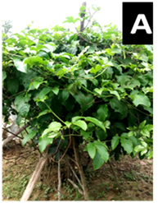 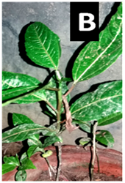 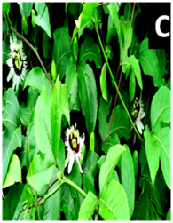

**Figure 3.1.1: *Passiflora edulis* var. *flavicarpa* Deg.**

1. Plant Habit; (B) Growing Plant; (C) Plant body with flowers

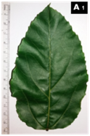 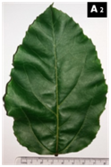 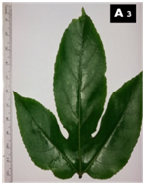 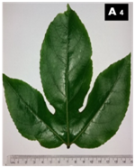

**Figure 3.1.2: *Passiflora edulis* var. *flavicarpa* Deg.** (A1 to A4) Heterophyllic leaves

*3.2 Flower*

Flower 7cm, axillary tendrils, solitary, hermaphrodite, actinomorphic; Bract or epicalyx, 2.5-3 cm, green; Coronal filaments numerous, 2-3cm, each filament purple at the root, white in the centre and at the tip; Sepals-5, Green, Oblong, length 3.5-4cm, width 1-1.5cm; Petals-5, white, length 2.5-3cm, width 0.5-1cm. Androecium: Androgynophore, Stamen-5, 1.4cm, Anther yellow, 1-1.2cm; filament green, linear. Gynoecium: Carpel-3, united,1.5-2cm; Ovary globose, yellow, 0.5cm, superior, unilocular; style yellowish green, 0.5-0.8cm; stigma green, length 0.5cm and width 0.5cm.

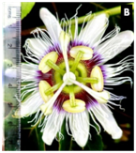 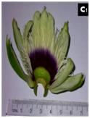 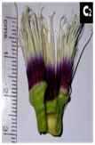 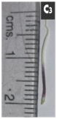 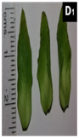

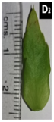 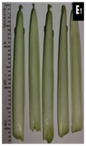  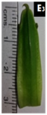 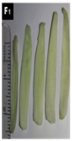 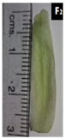  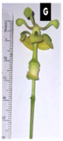

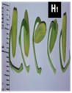 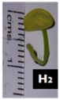 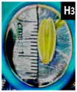 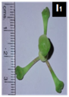 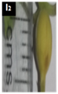  **Figure 3.2: *Passiflora edulis* var. *flavicarpa* Deg. Floral morphology and measurements.**

(B) Complete flower; (C1) Coronal filaments with petals and sepals; (C2) Coronal filaments; (C3) Single Coronal filament; (D1, D2) Bracts; (E1, E2, E3) Sepals; (F1, F2, F3) Petals; (G) Carpels and stamens; (H1) Stamens; (H2) Single stamen; (H3) Anther; (I1) Carpels; (I2) Ovary; (I3) Style; (I4) Stigma.

*3.3**Fruit*

The fruit is berry, globose, maturing state green in colour, while ripening turns yellowish colour, overall colour greenish-yellow, 6-7cm; presence of peduncle; 3 stigmas are distinct at the base of the fruit, black; Fruit section diameter 5.5 - 6cm, epicarp, mesocarp, endocarp, axial placentation, Seed size: length 1.2cm, width 0.5-0.6cm, pale yellow, taste sour.

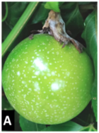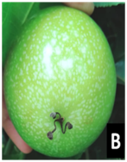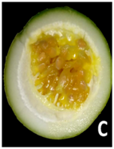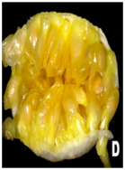

**Figure 3.3.1**: ***Passiflora edulis* var. *flavicarpa* Deg. Fruit:**

(A)Entire fruit (B)Basal portion (3 stigmas) (C) Fruit Section (D) Seeds

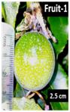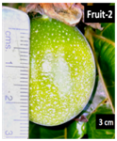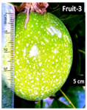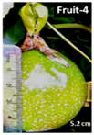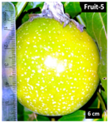

**Figure 3.3.2: *Passiflora edulis* var. *flavicarpa* Deg.**

Fruit-1 (2.5cm), Fruit-2 (3cm), Fruit-3 (5cm), Fruit-4 (5.2cm), Fruit-5(6cm).

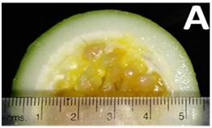 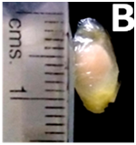 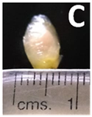

**Figure 3.3.3: *Passiflora edulis* var. *flavicarpa* Deg.**

(A) Fruit Section 5.5cm;(B) Seed length1.2cm;(C) Seed width 0.5-0.6cm

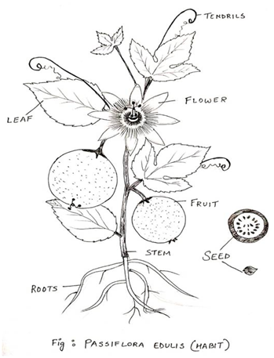

**Figure 3.4. *Passiflora edulis* var. *flavicarpa* Deg.** (Diagrammatic Representation)

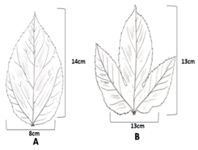 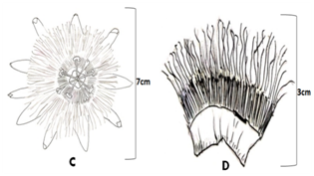

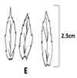 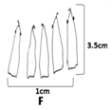 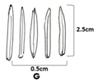 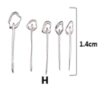 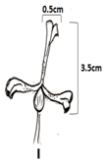

**Figure 3.5**: Floral morphology of ***Passiflora edulis* var. *flavicarpa* Deg.** (Diagrammatic Representation) (A), (B) Leaf (C) Flower (D) Coronal filaments (E) Bracts (F) Sepals (G) Petals (H) Androecium (Andogynophore) (I) Gynoecium.

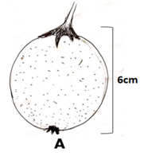 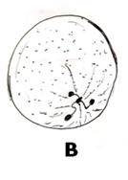 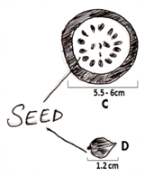

**Figure 3.6.*****Passiflora edulis* var. *flavicarpa* Deg.** (Diagrammatic representation)

(A) Entire fruit; (B) Basal portion (3 stigmas); (C) Fruit Section containing seeds; (D) A single seed.

1. **Medicinal and Economic Importance**

In majority of villages or Gaon in Assam, the old-aged local peoples or the ethnic groups, especially in the Upper Assam, sometimes in the Ahom Kingdom ruling period from 1228 AD to 1826 AD, and till now, it always comes under consideration that villagers have a very high indigenous knowledge of most medicinal plants and they have utilized the possible resources from many centuries as a medicine and food. The vernacular name of the medicinal plant ‘*Passiflora edulis* var. *flavicarpa*’ is also known as ‘Rashna tenga’ among the various ethnic groups of people in Assam. The word ‘Rashna’ indicates ‘juice’ or in Assamese language ‘rokh’ representing fruit juice and ‘tenga’ means ‘sour’ the taste of the fruit. So, agronomically, *Passiflora edulis* could be an important fruiting plant and also, that goes same to the economical point of view (Sarmah and Saikia, 2014). *Passiflora edulis* var. *flavicarpa* one of the main species of the Passifloraceae family, known for its several medicinal values. The fruit of *Passiflora edulis* contains carotenoid pigments and during the stages of fruit development from young to matured state, those pigments increase gradually (Pruthi and Lal, 1958). Some of vital medicinal properties found in *Passiflora edulis* includeanti-oxidant, anti-fungal, anti-inflammatory, anti-anxiety, anti-tumor and anti-hypertensive properties (Neog and Bora, 2018). Thus, the mentioned properties make *P. edulis* more interesting to conduct an investigation for researchers. *P edulis* Sims f. *flavicarpa* pulp juice has extensive use in treating patients suffered from hemorrhagic diseases due to the presence of the protein trypsin inhibitor and peptide anticoagulant (Sato et al., 2012). The fruit of *Passiflora edulis* constitutes 75mg/ 100g of ascorbic acids (Khare, 2007). A phytochemical study conducted on *Passiflora edulis* reported that the plant contains phenols, alkaloids, cyanogenic compounds and glycosyl flavonoids and also another active compound chrysin that occurs naturally (Ingale and Hivrale, 2010). An investigation conducted on *Passiflora edulis* in Nagaland state of North East India revealed that Naga peoples used to boiled the fresh leaves in water and the resultant extract was used to drink as a treatment of dysentery and also during hypertension (ZAS and John, 2016). In many species of *Passiflora* including *P edulis* Sims., the flowers that grows within each species were known to carry vital medicinal components such as sedative, anxiolytic activity, antispasmodic and a few others (Ramaiya et al., 2014). A well matured fruit of *Passiflora* consist of nearly 250 seeds which are edible and the interesting point to take a key note from those seeds is that it contains an antifungal protein known as Passiflin (Lam and Ng, 2009). In case of *Passiflora* species, like flower and fruits the leaves are also equally known to produce essential bioactive components that shows anxiolytic and sedative effects (Yuldasheva et al., 2005).

In case of *Passiflora quadrangularis*, two major components - isoorientin and isovitexin were detected in their leaves (Sakalem et al., 2012). Few research studies claim that *Passiflora* species were also used to obtain cyclopentene, valine or isoleucine and toxins such as cyanogenic glycosides i.e, from *Passiflora lutea, one* of the main species of *Passiflora* from where cyanogenic glycosides were derived (Spencer and Seigler, 1985). The presence of such cyanogenic glycosides in *Passiflora* species provides an opportunity to identify vital constituents of informative taxonomic markers, although, cyanogenic glycosides are also most commonly noticed in some families such as Rosaceae, Leguminosae and Compositae (Bolarinwa et al., 2016). The seeds of *Passiflora edulis* var *flavicarpa* Deg. after the juice isolated from the fruit are normally discarded as a by-product and those seeds possess a high quantity of the unsaturated fatty acids including- oleic acid and also linoleic acid (Liu et al., 2009). As shown in the figure:4, when seeds extracted from three passion fruits of newly developed fruit, matured fruit and pure ripened fruit (Yellow coloured) were applied in a proper combination in a container and allowed to run in an electric juice mixer for about 2minutes it resulted up to a quantity of 100ml juice. An interesting point to take a keynote is that normally the taste of passion fruit juice is sour but the combination of newly developed, matured and ripened fruit juice results into a different taste of a little bit of sweet-sour and also it was found that the odor was similar to pineapple juice (*Ananas comosus*).

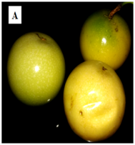 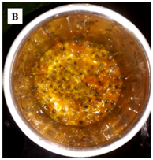 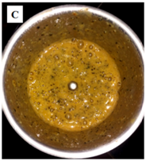

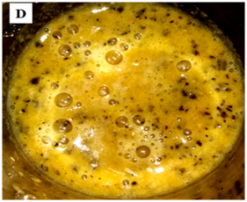 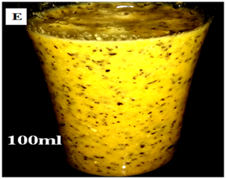

**Figure 4:** ***Passiflora edulis* var. *flavicarpa* Deg.** Fruit: Passion fruits juice of 100ml.

Since, the species of *Passiflora* mainly *P. edulis* possessing a high amount of medicinal value, an important fruit crop, also used as food material in diverse ways by most ethnic groups of North East India, it will give more profit both agronomically and economically, only if the cultivation will be proper as well as dynamic in the entire state, then production capacity will be ultimately increased.

1. **Discussion and Conclusion**

From the taxonomical point of view, *Passiflora edulis* var. *flavicarpa* Deg. could be regarded as a complete flower due to the presence of every floral part, the pattern of arrangement, that was detected through the present investigation conducted in April, 2020, at Nakachari Area, Jorhat District of Assam, India. The coronal filaments, figure 3.2(C2), of nearly 2-3cm, figure 3.2(C3), were of key attraction and a diagnostic character of *Passiflora edulis* var. *flavicarpa*, belonging to the family Passifloraceae. The tendrils, figure 3.4, provides physical support for a growing plant body came under observation. All stages from the bud formation to a proper blooming flower till the fruit development of *Passiflora edulis* var. *flavicarpa* were recorded within May, 2020. It was observed that for the proper development of Passion fruit, figure3.2, it takes probably 13 to 16 days from the day-1 of fruit forming stage. *P edulis* is a very rich plant due to a large percentage of essential medicinal properties that could be extracted from leaves and fruit, mostly, for disease treatment. Man’s ultimate dependency on medicinal plants from ancient times indicates the importance of each and every other flora including the species of *Passiflora*. Now, it’s high time to cultivate the best possible resources and at the same time not to destroy the blessings of natural resources by deforestation or through any other means (Sofowora, 1996).

**References**

Barnes, J., Anderson, L. and Phillipson, D. (2007). Herbal Medicines.Pharmaceutical Press Publication, London, Chicago. 3rd edn. Pp. 461-469.

Bolarinwa, I.F., Oke, M.O., Olaniyan, S.A. and Ajala, A.S. (2016). A Review of Cyanogenic Glycosides in Edible Plants. Toxicology–New Aspects to This Scientific Conundrum,8:180-191. [*http://dx.doi.org/10.5772/64886*](http://dx.doi.org/10.5772/64886)

Bombardelli, E., Bonati, T., Gabetta, B., Martinelli, E.M., Mustich, G. and Danieli, Bruno. (1975). Passiflorine, a new glycoside from *Passiflora edulis.* Phytochemistry, 14(12): 2661-2665. [*https://doi.org/10.1016/0031-9422(75)85246-0*](https://doi.org/10.1016/0031-9422(75)85246-0)

Brickell, C. (2019). Encyclopedia of Plants and Flowers. Dorling Kindersley Publication, London. 4th edn. Pp. 188-204.

*http/www.plantlist.org.*

*http/www.ipni.org.*

Ingale, A.G. and Hivrale, A.U. (2010). Pharmacological studies of *Passiflora* sp. and their bioactive compounds. African Journal of Plant Science, 4(10): 417-426.

Jain, S.K. and Rao, R.R. (1977). A Handbook of Field and Herbarium Methods.Today and Tomorrow's Publication, New Delhi.

Khare, C.P. (2007). ‘Indian Medicinal Plants’ An Illustrated dictionary. Springer publication, pp: 465.

Lam, S.K. and Ng, T.B. (2009). Passiflin, a novel dimeric antifungal protein from seeds of the passion fruit. Phytomedicine, 16(2-3): 172-180.

[*https://doi.org/10.1016/j.phymed.2008.12.025*](https://doi.org/10.1016/j.phymed.2008.12.025)

Liu, S., Yang, F., Zhanga, C., Ji, H., Hong, P. and Deng, C. (2009). Optimization of process parameters for supercritical carbon dioxide extraction of *Passiflora* seed oil by response surface methodology. The Journal of Supercritical Fluids,48(1):9-14.

[*http://dx.doi.org/10.1016/j.supflu.2008.09.013*](http://dx.doi.org/10.1016/j.supflu.2008.09.013)

Mipun, P., Borah, D., Ahmad, B.N. and Kumar, Y. (2019). Checklist for Phytodiversity of East Karbi Anglong Wildlife Sanctuary, Assam, Northeast India: Part I. Ambient Science, 06(2). [*https://doi.org/10.21276/ambi.2019.06.2.aa03*](https://doi.org/10.21276/ambi.2019.06.2.aa03)

Montanher, A.B., Zucolotto, S.M., Schenkel, E.P. and Frode, T.S. (2007). Evidence of anti-inflammatory effects of *Passiflora edulis* in an inflammation model. Journal of Ethno-pharmacology,109(2):281–288. [*https://doi.org/10.1016/j.jep.2006.07.031*](https://doi.org/10.1016/j.jep.2006.07.031)

Neog, J.G. and Bora, T. J. (2018). Phytochemical Analysis of *Morus alba* and *Passiflora edulis* fruit extracts in Assam. International Journal of Multidisciplinary Research Review, 1(37):66-68.

Patel, S.S. (2009). Morphology and Pharmacology of *Passiflora edulis*: A review. Journal of Herbal Medicine and Toxicology,3(1):1-6.

Patel, S.S., Soni, H., Mishra, K. and Singhai, K.A. (2011). Recent updates on the genus *Passiflora*: A review. International Journal of Research in Phytochemistry & Pharmacology,1(1): 1-16.

Pruthi, J.S. and Lal, G. (1958). Carotenoids in Passion fruit juice (*Passiflora edulis,* Sims.). Journal of Food Science, 23(5):505-510.

Ramaiya, S.D., Bujang, J.S. and Zakaria, M.H. (2014). Assessment of Total Phenolic, Antioxidant, and Antibacterial Activities of *Passiflora* Species. The Scientific World Journal,1-10. [*https://doi.org/10.1155/2014/167309*](https://doi.org/10.1155/2014/167309)

Sakalem, M.E., Negri, G. and Tabach, R. (2012). Chemical composition of hydroethanolic extracts from five species of the *Passiflora* genus. Revista Brasileira de Farmacoggonosia Brazilian Journal of Pharmacognosy,22(6):1219-1232.

[*http://dx.doi.org/10.1590/S0102-695X2012005000108*](http://dx.doi.org/10.1590/S0102-695X2012005000108)

Sarmah, R. and Saikia, A. (2014). Non-Timber forest products: Diversity and Used pattern at Majuli the Brahmaputra River Island of Assam, India. Research and Reviews: Journals of Botanical Sciences,3(3): 41-47.

Sato, A.C., Andrade, S.A., Brito, M.V., Miranda, A., Sampaio, M.U., Maffei, F.H. de A. and Oliva, M L V. (2012). Effects of Compounds from *Passiflora edulis* Sims f. *flavicarpa* Juice on Blood Coagulation and on Proteolytic Enzymes. Protein & Peptide Letters,19(5): 501-508. [*https://doi.org/10.2174/092986612800191053*](https://doi.org/10.2174/092986612800191053)

Sofowora, A. (1996). Research on Medicinal Plants and Traditional Medicine in Africa. The Journal of Alternative and Complementary Medicine,2(3):365-372.

[*https://doi.org/10.1089/acm.1996.2.365*](https://doi.org/10.1089/acm.1996.2.365)

Spencer, K.C. and Seigler, S.D. (1985). Co-occurrence of Valine/Isoleucine-Derived and Cyclopentenoid Cyanogens in a *Passiflora* species. Biochemical Systematics and Ecology,13(3):303-304. [*https://doi.org/10.1016/0305-1978(85)90039-0*](https://doi.org/10.1016/0305-1978(85)90039-0)

Tripathi, P.C. (2018). Passion Fruit. (In) Peter, K V (Ed). Horticultural Crops of high

nutraceutical values. Brillion Publishing New Delhi, Pp: 245-270.

Yuldasheva, L.N., Carvalho, E.B., Catanho, M-T J.A. and Krasilnikov, O.V. (2005). Cholesterol- dependent hemolytic activity of *Passiflora quadrangularis* leaves. Brazilian Journal of Medical and Biological Research, 38(7):1061-1070.

[*https://doi.org/10.1590/S0100-879X2005000700009*](https://doi.org/10.1590/S0100-879X2005000700009)

ZAS, Phamiwon. and John, S. (2016). Diabetes and Medicinal benefits of *Passiflora edulis.* World Journal of Pharmaceutical Research,5(3):453- 465.