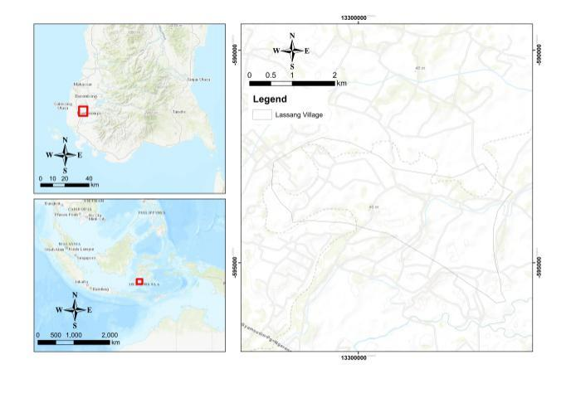

Figure 1 Lassang Map (source: google earth)

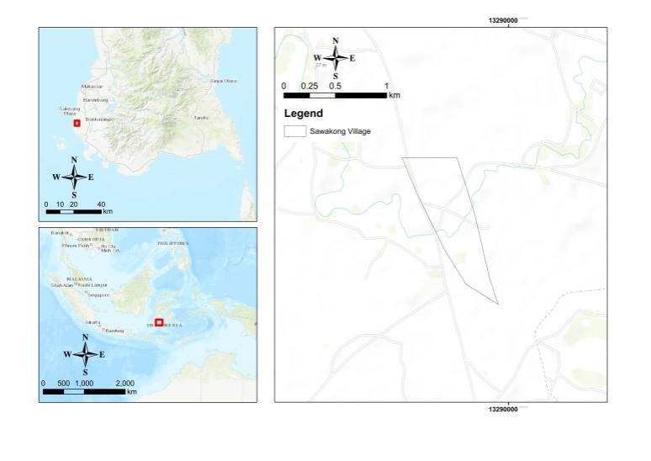

Figure 2 Sawakong Map (source: google earth)

Table 1 Variables of marital satisfaction, job satisfaction, and decision-making

Part | Variables |  | Description of Indicator
Marital Satisfaction | Household Responsibility | Social process related to the wellbeing of families and construction of gender.
Marital Satisfaction | Raising Children | Financial and emotional resources devoted to raising children.
Marital Satisfaction | Consciousness | Statement about point of view of spouse and how the respondent resolves conflict in marriage.
Marital Satisfaction | Partnership | Support in workplace and communication with partner (discuss problems faced by couple).
Job Satisfaction | Enjoyment of Work | Assesses whether workers have a dream job, a comfortable job, or a comfortable workplace. Farming is a regular part of their lives.
Job Satisfaction | Leisure Time | Examines the relationship between work hours and leisure time among female farmers.
Job Satisfaction | Work Environment | One of the key challenges for any business is to satisfy its employees in order to adapt to the ever-changing and evolving environment, achieve success, and remain competitive. To increase employee efficiency, effectiveness, productivity, and job commitment, businesses must satisfy employee needs by providing good working conditions.
Job Satisfaction | Economic Dimension | Women in agriculture are more likely to work as unpaid family labourers. Salary and other material benefits emerge as a significant dimension of satisfaction in almost all studies of employee satisfaction.
Decision-Making | Thoroughness | Refers to a careful and comprehensive approach to choosing a course of action.
Decision-Making | Control | Control systems are grounded in the idea that people will unfailingly accept legitimate authority.
Decision-Making | Hesitancy | Refers to slowness in acting or deciding due to doubt or uncertainty.
Decision-Making | Social Resistance | Refers to collective actions or attitudes taken by individuals or groups to oppose or challenge a decision made by those in power.
Source : author
Table 2 Socioeconomic characteristics of the respondents
Factor |  |  | Lassang |  |  | Sawakong
 |  |  | n=29 | Mean | SD | n=41 | Mean | SD
Age (years) |  |  |  | 38.55 | 9.6 |  | 34.77 | 10.19
 |  | Under 20 | 1 | 38.55 | 9.6 | 3 | 34.77 | 10.19
 |  | 21–30 | 4 | 38.55 | 9.6 | 12 | 34.77 | 10.19
 |  | 31–40 | 12 | 38.55 | 9.6 | 13 | 34.77 | 10.19
 |  | 41–50 | 8 | 38.55 | 9.6 | 10 | 34.77 | 10.19
 |  | 51–60 | 4 | 38.55 | 9.6 | 3 | 34.77 | 10.19
Educational Background |  |  |  | 7.24* | 3.9 |  | 10.43* | 3.1
 | No Education |  | 5 | 7.24* | 3.9 | 0 | 10.43* | 3.1
 | Elementary School |  | 8 | 7.24* | 3.9 | 9 | 10.43* | 3.1
 | Junior High School |  | 10 | 7.24* | 3.9 | 10 | 10.43* | 3.1
 | Senior High School |  | 6 | 7.24* | 3.9 | 17 | 10.43* | 3.1
 | Undergraduate |  | 0 | 7.24* | 3.9 | 5 | 10.43* | 3.1
Farmland Size (hectares) |  |  |  | 0.67 | 0.89 |  | 0.18 | 0.46
 | 0.1–1 |  | 0 | 0.67 | 0.89 | 10 | 0.18 | 0.46
 | 1.1–2 |  | 2 | 0.67 | 0.89 | 5 | 0.18 | 0.46
 | 2.1–3 |  | 1 | 0.67 | 0.89 | 6 | 0.18 | 0.46
 | 3.1–4 |  | 0 | 0.67 | 0.89 | 0 | 0.18 | 0.46
 | Landless Farmer |  | 26 |  |  | 20
Off-Farm Work
 | Crafting |  | 0 |  |  | 21
 | Teacher |  | 0 |  |  | 3
 | Shop Owner |  | 5 |  |  | 7
 | Livestock |  | 22 |  |  | 7
 | Other |  | 2 |  |  | 3
Total Household Income (IDR/month) |  |  |  | 1098.1 | 622.94 |  | 931.21 | 498.76
 | 0–500.000 |  | 4 |  |  | 9
 | 501.000–1.000.000 |  | 12 |  |  | 23
 | more than 1.000.000 |  | 13 |  |  | 9
* Years in education

Table 3 Respondents’ score on marital satisfaction, job satisfaction, and decision-making
 |  |  | Perfect Score | Max | Min | Mean | SD
Marital Satisfaction (n=70) |  |  | 85 | 77 | 30 | 56 | 9.176
 |  | Household  Responsibility | 25 | 23 | 7 | 17.9 | 33.2
 |  | Raising Children | 20 | 20 | 7 | 14.3 | 19.4
 |  | Consciousness | 25 | 25 | 6 | 16.9 | 21.6
 |  | Partnership | 15 | 15 | 5 | 10.6 | 42.3
Job Satisfaction On-Farm (n=70) |  |  | 85 | 71 | 25 | 52.87 | 8.875
 | Enjoyment of Work |  | 20 | 17 | 5 | 12.61 | 18.01
 | Leisure Time |  | 15 | 14 | 3 | 9.6 | 31.05
 | Work Environment |  | 25 | 22 | 8 | 13.26 | 30.96
 | Economic Dimension |  | 25 | 23 | 6 | 14.41 | 11.1
Job Satisfaction Off-Farm (n=70) |  |  | 55 | 50 | 27 | 36.2 | 6.35
 | Enjoyment of Work |  | 20 | 19 | 5 | 12.61 | 12.8
 | Work Environment |  | 15 | 14 | 3 | 9.67 | 19.9
 | Economic Dimension |  | 20 | 19 | 6 | 14.1 | 15,4
Decision-Making (n=70) |  |  | 65 | 55 | 24 | 42.2 | 6.88
 |  | Control | 25 | 23 | 8 | 16.2 | 31.21
 |  | Social | 15 | 15 | 3 | 10 | 26.58
 |  | Hesitancy | 10 | 10 | 2 | 6.19 | 3.53
 |  | Thoroughness | 15 | 15 | 4 | 9.86 | 21

Table 4 Correlation between marital satisfaction, job satisfaction, and decision-making
 |  | Marital | Job On-Farm | Job Off-Farm | Decision-Making
Marital | Pearson Correlation | 1 | .445** | .213* | .232*
Marital | Sig. (2-tailed) |  | .000 | .076 | .054
Marital | N | 70 | 70 | 70 | 70
Job On-Farm | Pearson Correlation | .445** | 1 | .481** | .489**
Job On-Farm | Sig. (2-tailed) | .000 |  | .000 | .000
Job On-Farm | N | 70 | 70 | 70 | 70
Job Off-Farm | Pearson Correlation | .213* | .481** | 1 | .345**
Job Off-Farm | Sig. (2-tailed) | ,076 | .000 |  | .003
Job Off-Farm | N | 70 | 70 | 70 | 70
Decision-Making | Pearson Correlation | .232* | .489** | .345** | 1
Decision-Making | Sig. (2-tailed) | .054 | .000 | .003
Decision-Making | N | 70 | 70 | 70 | 70
** Correlation is significant at the 0.01 level (1-tailed)
* Correlation is significant at the 0.05 level (1-tailed)

Table 5 Effect of farmland ownership on marital satisfaction and job satisfaction
 |  | B | SE | Wald | df | Sig. | Exp(B)
Step 1ª | Marital | −.044 | .043 | 1.038 | 1 | .308 | .957
Step 1ª | On-Farm | 059 | .051 | 1.328 | 1 | .249 | 1.061
Step 1ª | Off-Farm | .079 | .058 | 1.881 | 1 | .170 | 1.082
Step 1ª | Farmland | −3.485 | 2.681 | 1.690 | 1 | .194 | .031
a. Variable(s) entered on step 1: Marital, On-farm, Off-farm, Farmland.

Table 6 Effect of total revenue on marital satisfaction and job satisfaction

Independent Variable | Model I | Model 2 | Model 3
Dv Total Income
Marital Satisfaction^{c} | 1.805 (0.043)** | 477.504 (<.001)* | 6.610 (0.14)
On-farmª | 1.059 (0.422) | 305.148 (<.001)* | .933 (.339)
Off-farm^{b} | 3.948 (<.001)* | 749.024 (<.001)* | 54.589(<.001)*

a. R Squared = .361 (Adjusted R Squared = .020)(on-farm proportion)
b. R Squared = .678 (Adjusted R Squared = .506)(off-farm proportion)
c. R Squared = .490 (Adjusted R Squared = .219) (marital proportion)

Table 7 Effect of educational background on marital satisfaction and job satisfaction
 |  | Marital | Job On-Farm | Job Off-Farm
Educational Background | Pearson Correlation | .295* | .378** | .290*
Educational Background | Sig. (2-tailed) | .013 | .001 | .015
Educational Background | N | 70 | 70 | 70
** Correlation is significant at the 0.01 level (2-tailed)
* Correlation is significant at the 0.05 level (2-tailed)

